((PLACE ON ORGANIZATION LETTERHEAD AND DELETE THIS TEXT))

WHEREAS, The (name of signer) hereby declares on this date of (date) , that
(name of Organization) is a TraffickingFree Zone.

WHEREAS, human sex trafficking is a form of modern day slavery and occurs when an adult or child is recruited, harbored, obtained, or exported through force, fraud or coercion for the purposes of sexual exploitation; and

WHEREAS, Florida consistently ranks third in the Nation for the number of calls made to the National Human Trafficking Hotline, human sex trafficking is growing throughout Pinellas County, Florida and the United States, thriving in cities across geographic and socio-demographic variability, and nationally, the criminal enterprise of human trafficking is second only to the illegal drug trade, in terms of the speed of its growth and being among the most lucrative, and;

WHEREAS, human sex trafficking significantly threatens the safety and well-being of the child victims, some as young as infants, and often coming from the foster care system, and vulnerable adults being purchased, as well as the families of buyers, legitimate businesses and our communities; and

WHEREAS, there is a growing body of evidence that targeting sex buyers is a pragmatic, effective way to reduce demand within the commercial sex industry; and

NOW, THEREFORE, BE IT RESOLVED, that (name of Organization) will continue our efforts to combat the commercial sexual exploitation of our children and vulnerable adults, and mitigate the associated public safety, economic, and health risks to our community, in collaboration with the U.S. Institute Against Human Trafficking, and other anti-human trafficking organizations by;

COMBATING COMMERCIAL SEXUAL EXPLOITATION THROUGH COMPREHENSIVE EDUCATION OF OUR EMPLOYEES, AND THE IMPLEMENTATION AND ENFORCEMENT OF A ZERO-TOLERANCE POLICY AGAINST ANY ACT WHICH MAY SUPPORT THE SEX TRAFFICKING OF HUMANS

And ask the citizens of Pinellas County to join (name of Organization) in promoting a shift away from the culture of tolerance toward human trafficking.

((Signature))
((Name))
((Title))
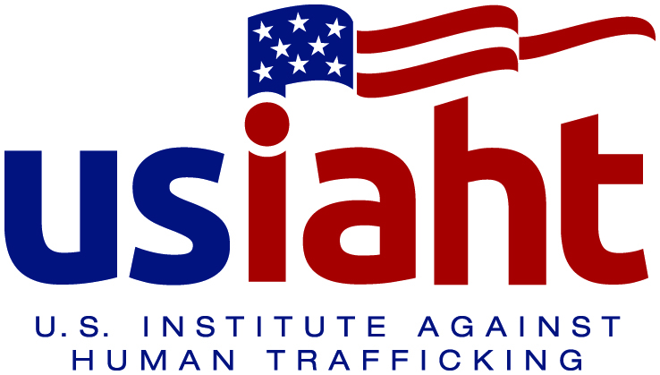
YOUR
LOGO/SEAL
HERE
